Singular Value Decomposition (SVD)

What is SVD?
Singular Value Decomposition (SVD) is a matrix decomposition that works for every matrix, whether it is:
- Square or rectangular
- Symmetric or non-symmetric
- Full rank or rank deficient

For any matrix
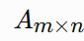
there exist matrices U, Σ, and V such that
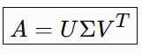

Components of SVD

(a) Matrix U
- Called the Left Singular Vector Matrix
- Columns are orthonormal
- Obtained from the eigenvectors of
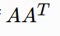

(b) Matrix Σ
Contains the Singular Values
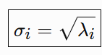
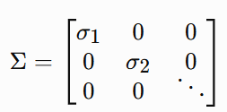

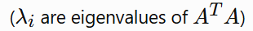
Singular values are always
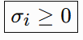

(c) Matrix V
- Called the Right Singular Vector Matrix
- Columns are orthonormal
- Obtained from the eigenvectors of

Example
Find the SVD of
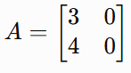

Step 1 : Compute
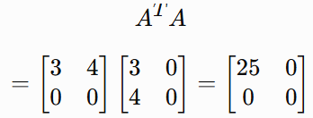

Step 2 : Find eigenvalues. Since the matrix is diagonal,
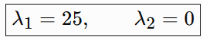

Step 3 : Find eigenvectors for
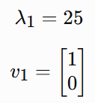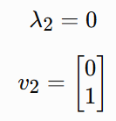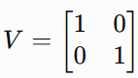

Step 4: Find singular values
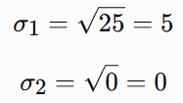

Step 5 : Find the first left singular vector
Using
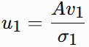
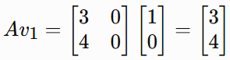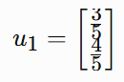

Step 6: Find the second left singular vector. It must be orthogonal to u1. It uses the same formula as u1 used before.
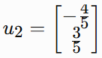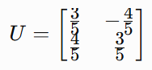

Step 7
Final Answer
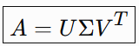
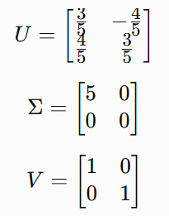
Matrix | Obtained from
V | Eigenvectors of A^{T}A
Σ | Square roots of eigenvalues of A^{T}A
U | 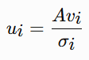

Positive Definiteness
Positive definiteness is used to determine whether a quadratic function has a minimum, maximum, or saddle point. It is also an important concept in optimization and machine learning (e.g., Hessian matrices, convexity).

1. Quadratic Function
A quadratic function in two variables is
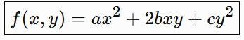
Where a,b,c are constants.
Example:
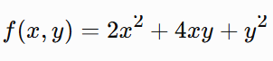
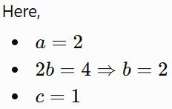

2. Stationary Point
A stationary point is a point where all first-order partial derivatives are zero.
Step 1: Find Partial Derivatives
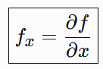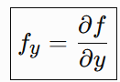

Step 2: Set Them Equal to Zero
Solve
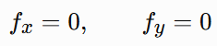
The solution gives the stationary point.

Example
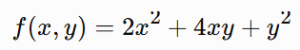
Partial derivatives:
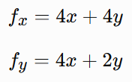
Set equal to zero:
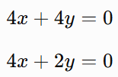
Subtract:
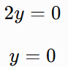
Substitute back:
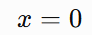
Stationary point:
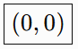

Matrix Form
Example
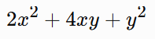
The quadratic function
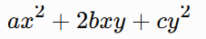
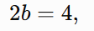
can be written as
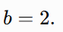
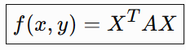
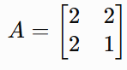
Where
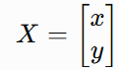
and
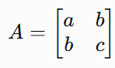

Condition | Result | Shape
a>0, ac>b² | Positive Definite | Bowl (Minimum)
a>0, ac=b² | Positive Semi-Definite | Flat Bowl
ac<b² | Saddle Point (Indefinite) | Saddle
a<0, ac>b² | Negative Definite | Upside-down Bowl (Maximum)

Positive Definiteness Matrices

Positive Definite Matrices
1. Definition
For a real symmetric matrix A, we say A is positive definite if
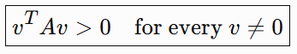
Here, v^{T}Av is called a quadratic form.
2. Main Theorem
For a real symmetric matrix A,
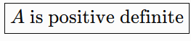
if and only if
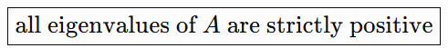
In other words,
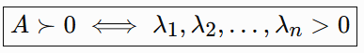
This is the key result to remember.
What to remember for exams
For a symmetric matrix:
Eigenvalues | Matrix
All >0 | Positive definite
All ≥0 | Positive semidefinite
All <0 | Negative definite
Mixed positive & negative | Indefinite

Principal Component Analysis (PCA)

1. What is PCA?
PCA (Principal Component Analysis) is a dimensionality reduction technique.
Given data in d-dimensions, PCA finds a lower-dimensional subspace of dimension m, where, m<d such that the information lost during projection is minimized.

2. Two interpretations of PCA
PCA can be understood in two equivalent ways:

View 1 — Minimize reconstruction error
Project the data onto a lower-dimensional subspace and find the subspace that gives the smallest reconstruction error.
This is the viewpoint used in this lecture.

View 2 — Maximize variance
Find directions onto which the projected data has the maximum variance.
Both approaches lead to the same principal components.
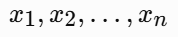
Where
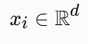
We want to represent these d-dimensional points using only an m-dimensional subspace:
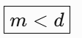
The objective is:
Find an m-dimensional subspace that minimizes reconstruction error

Example
Suppose our dataset is
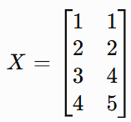
Step 1: Calculate the mean vector
Mean of the first feature:
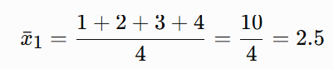
Mean of the second feature:
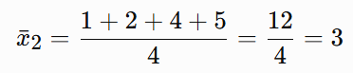
Therefore,
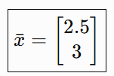

Step 2: Center the data
We subtract the mean from every observation:
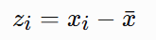
For the first point:
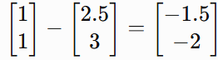
Similarly,
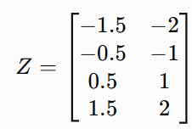
Check:
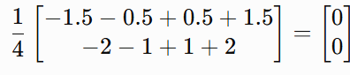
So the data is correctly centered.

Step 3: Calculate the covariance matrix
For centered data,
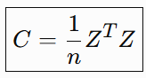
Here,
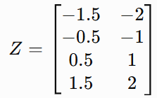
Therefore,
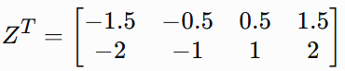
Now multiply:
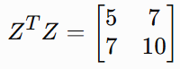
Since n=4,
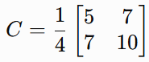
Therefore,
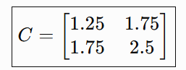

Step 4: Find eigenvalues
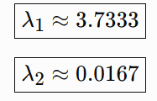
We solve
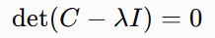
So,
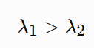
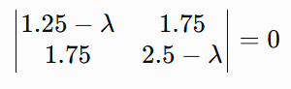
Notice that
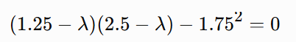
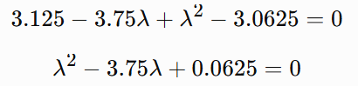

Step 5: Find the principal eigenvector
Because we're reducing to 1 dimension, we need only the eigenvector corresponding to the largest eigenvalue:
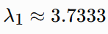
Now solve with this
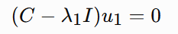
So our first principal component direction is
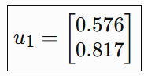
Step 6: Project the data onto the principal component
This is the important PCA step.
For each centered data point,
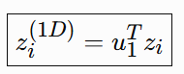
Therefore, our original 2D data has been converted to:
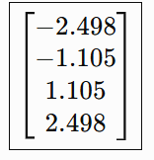
This is now 1-dimensional data.

Step 7: Convert a 1D value into a vector
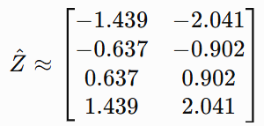
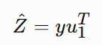
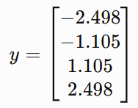

Step-8: Reconstruction Error
Now compare the centered original vector with the reconstructed centered vector.
For the first point:
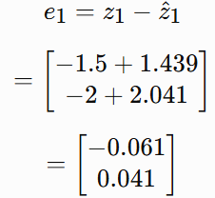
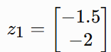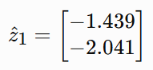

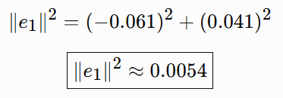
The total reconstruction error is
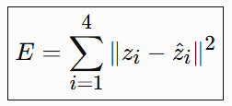

PCA connection
Eigenvalue=variance along its eigenvector​
Therefore PCA chooses the eigenvectors with the largest eigenvalues, because they retain the most variance.
For our example:
Component | Eigenvalue | Variance retained
PC1 | 3.733 | 99.56%
PC2 | 0.017 | 0.44%
This is why PC1 alone is enough for this dataset.

Structure of a Covariance Matrix
Suppose your dataset has 3 features:
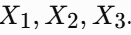
The covariance matrix is:
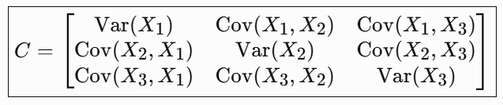

The important pattern:
Position | Meaning
Diagonal elements | Variance of each feature
Off-diagonal elements | Covariance between two features

Mathematical Foundations of Machine Learning
Machine Learning is built on three main mathematical pillars:

1. Linear Algebra
- Helps understand the structure and relationships in data.
- Used to represent data using vectors and matrices.
- Example: Modeling the relationship between height and weight.

2. Probability
- Helps handle uncertainty and noise in real-world data.
- Real data does not always follow a perfect pattern.
- Used to make predictions despite uncertainty.

3. Optimization
- Helps find the best solution or model from multiple possibilities.
- Minimizes errors or maximizes a desired objective.
- Example: Finding the best-fitting line for data.

Optimization in Machine Learning

What is Optimization?
Optimization helps machine learning algorithms make the best decision by:
- Minimizing loss/error
- Maximizing reward/performance

Cow in a Field Example
Goal: Find the best position for the cow to get as close as possible to the grass while following certain restrictions.

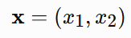
1. Variables
The cow's position:

2. Objective Function
Minimize the squared distance from the grass at (40,40):
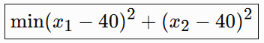

3. Constraints
The cow must satisfy:
- Rope constraint: Cannot move beyond the rope's allowed circular region.
- Fence constraint: Cannot cross the fence boundary.

General Optimization Framework
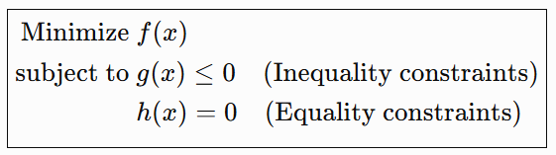
Component | Meaning
Variables x | Values we want to find
Objective f(x) | What we minimize or maximize
g(x)≤0 | Inequality restrictions
h(x)=0 | Exact equality requirements

Key Idea
Optimization = Find the best solution while satisfying all constraints.
Useful connection: In machine learning, the model parameters are the variables, and the loss function is the objective we optimize.

Unconstrained Optimization

🎯 What is Unconstrained Optimization?
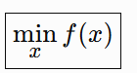
It means finding the minimum or maximum of a function without any restrictions (constraints).

📌 Example
Consider:
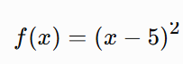
The minimum occurs at:
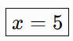

1. Traditional Derivative Method
To find the minimum mathematically:
- Calculate f′(x)
- Set f′(x)=0
- Solve for x
Problem: For complex machine learning functions, solving equations directly is often difficult or impossible.

2. Iterative Approach
Instead of solving directly, a computer:
- Starts with an initial guess x₀
- Repeatedly moves toward a better solution
- Continues until it reaches or gets close to the minimum
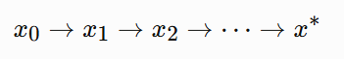

3. Choosing the Direction
The direction of movement is chosen as the negative derivative:

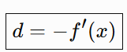

Why negative?
- f′(x)>0 → Function is increasing → Move left ⬅️
- f′(x)<0 → Function is decreasing → Move right ➡️
Thus, the negative derivative points toward decreasing function values.

4. The Step Size Problem
Moving in the correct direction is not enough—we must also decide how far to move.
A large step can cause overshooting and oscillation, such as jumping back and forth between two points instead of reaching the minimum.

Key Insight
Good Optimization = Correct Direction + Appropriate Step Size

This naturally leads to Gradient Descent, where a learning rate controls the step size.

Step Size in Unconstrained Optimization

🎯 Why Do We Need a Step Size?
In iterative optimization, moving in the negative derivative direction is not enough. We also need to decide how far to move.
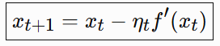

1. ⚠️ Oscillation Problem
- A large step size can overshoot the minimum.
- The algorithm may jump back and forth instead of converging.
➡️ Therefore, the step size should be carefully controlled.

2. First Attempt: Exponentially Decreasing Step Size
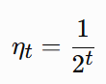
Although the step sizes decrease:
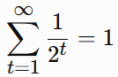

The total distance the algorithm can travel is finite.
❌ If the starting point is far from the minimum, the algorithm may never reach it.

3. Better Approach: Harmonic Step Size
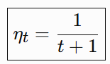
The step size becomes smaller over time, but:
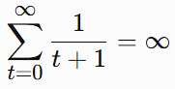
So the algorithm has the potential to travel an unlimited total distance.
✅ This gives it enough opportunity to reach the minimum even when starting far away.

Key Idea
A useful decreasing step-size sequence should balance two things:
Step sizes decrease+Total movement remains sufficient
This is an important foundation for understanding learning-rate schedules and Gradient Descent.

Gradient Descent

What is Gradient Descent?
Gradient Descent is a first-order optimization algorithm used to minimize a function iteratively. It is widely used in machine learning to minimize the loss function.

1. The Basic Idea
Starting from an initial point, repeatedly move in the direction of steepest decrease:

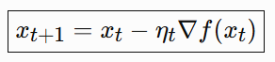
Where:
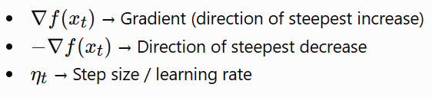

2. Convergence
Gradient Descent aims to reach a local minimum of the function.

Local Minimum
The lowest point within a small nearby region.

Global Minimum
The lowest point in the entire function.
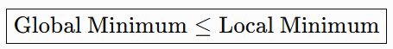

3. Convex Functions ⭐
For a convex function:
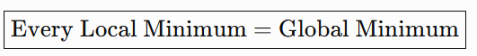
Therefore, Gradient Descent is especially effective for convex optimization problems.

Key Takeaway
Gradient Descent repeatedly moves in the negative gradient direction to minimize a function.

Why Gradient Descent Uses the Negative Gradient
The main question is:
Why do we move in the direction −f′(x) instead of some other direction?

1. Gradient Descent Update Rule
For a function f(x):
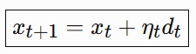
where:
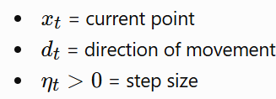
Gradient Descent chooses:
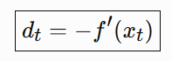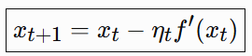

2. Use Taylor Expansion
Suppose we move from x to:
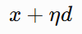
Taylor expansion gives approximately:
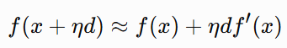
Therefore, the change in the function is:
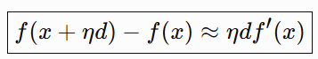
For a small η, higher-order terms can be ignored.

3. We Want the Function to Decrease
For descent, we need:
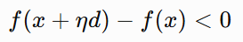
Since η>0, we need:
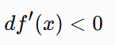
So the direction d and derivative f’(x) should have opposite signs.
4. Why Choose d=−f′(x)?
Set:
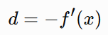
Then:
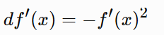
Since:
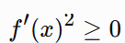
We get :

